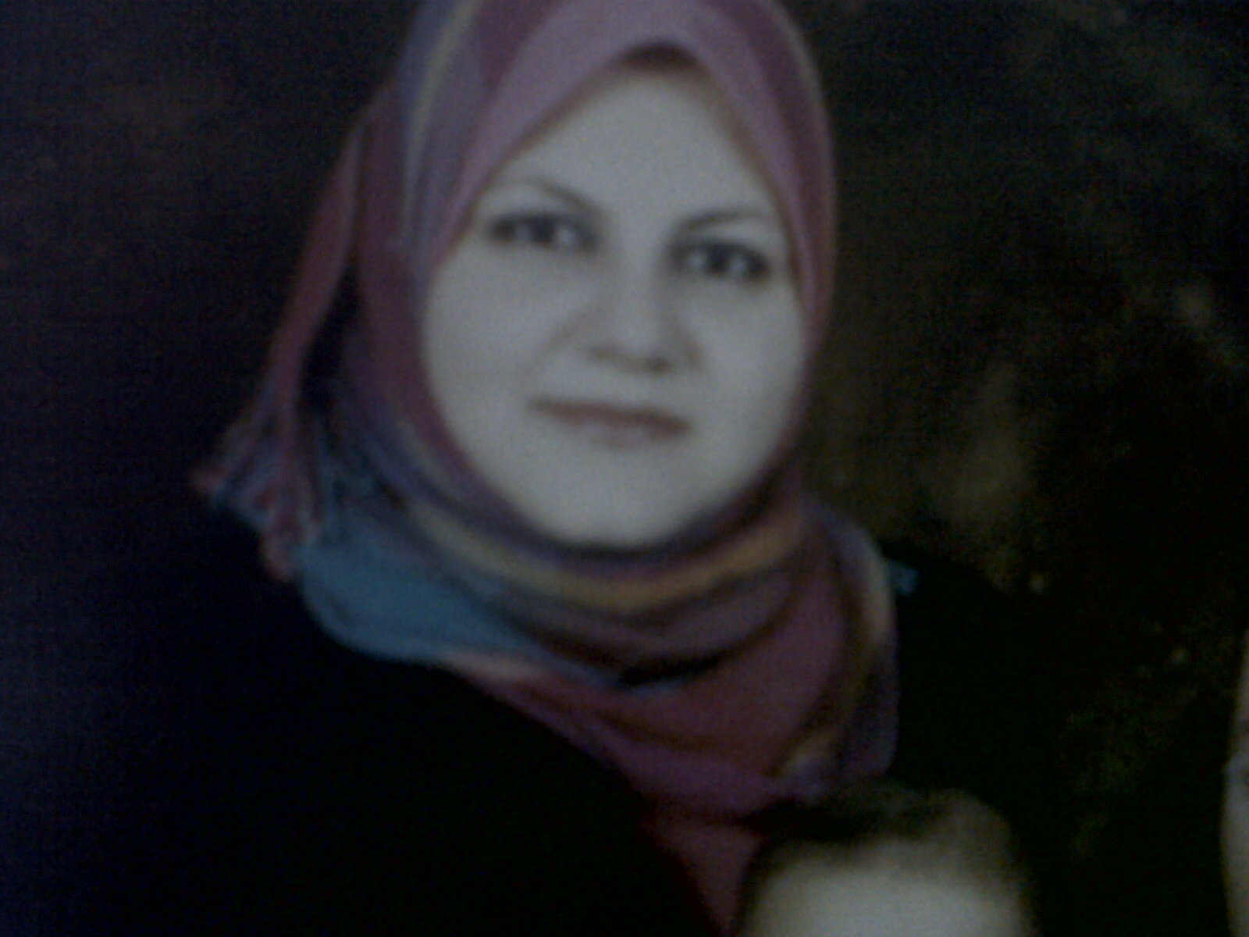
ASMAA NASR EL-DIN THABET
Date of Birth : 18/ 7 / 1981
Place of Birth : Egypt, Sohag.
Marital Status : Married with two children.
Sex : Female
Nationality : Egyptian
Religion : Muslim
Contact : E-mail; asmaanasreldin81@gmail.com
Telephone Number : +20932304199 (Home)
+201028090703

Languages : Arabic: Mother tongue. English: Very good
Employment History:
- Demonstrator of microbiology and immunology from 2007 to 2010
- Assistant lecturer of microbiology and immunology in faculty of medicine, Sohag University from 2010 to 2013.
- Lecturer of microbiology and immunology in faculty of medicine, Sohag University from july 2013 till now.
- Member of the Egyptian society of infection control.
- Member of the Egyptian society of microbiology and immunology.
- Member of the Quality Assurance Unit in faculty of medicine, Sohag University.
- Member in the infection control team of Sohag university hospitals

Educational background:
- M.D in microbiology and immunology, Faculty of medicine, Sohag University, Egypt, June 2013.
- M.Sc. in microbiology and immunology Faculty of Medicine, Sohag University, Egypt 2010.
- M.B.B.CH., September, 2004, Faculty of Medicine, Sohag University, Egypt.
- Publications in local and international journals in the field of microbiology and immunology.

Special Skills:
- Different diagnostic laboratory methods in bacteriology.
- Infection control training and surveillance programs.
- PCR technique.
- ELISA technique.
- Flowcytometry

Conferences Attendance:

- The annual meetings of the Egyptian society of microbiology and immunology.
- Workshop in molecular biology techniques 2011(molecular biology training center in Alexandria).
- Workshop in laboratory biosafety and its levels (Assiut University).
- The annual meetings of the Egyptian society of infection control.
- Workshop in PCR and flowcytometry as trainer (central lab. In faculty of medicine Sohag university 2013).
- Workshop in basic infection control standards for dentists as trainer (infection control unit of sohag university hospitals 2013).

Supervision on scientific messages:

1 Clinical and mycological profile of vaginal candidiasis in Sohag University Hospital: Dr. Mona Fattouh Mohamed Prof. Dr. Ahmed Hassan Abdelaziz Ashgan Hussien Badawy Dawood master degree

2 Detection of Cytokine Gene Polymorphism and Estimation of Its Serum level and It’s Correlation to Development of Hepatocellular Carcinoma in Sohag University Hospital Noha Saber Shafik Amin . Dr. Abeer Sheneef Mohmmad Dr. Asmaa Nasr ElDin Thabet. MD degree

3 MicroRNA-122: A new biomarker for diagnosis, treatment, and prognosis of chronic HCV. Esraa Farag Abo El-Hassan Mekheimer
Dr. Asmaa Nasr Eldin Thabet Dr. Mona Fattouh Mohamed Prof. Dr. Usama Ahmed Arafa.

4 Detection of MDR and XDR mycobacterial tuberculosis in cases of pulmonary TB in sohag governorate, Egypt.

5- Inhibition of quorum sensing character in pseudomonas aeruginosa isolates and its effect on biofilm formation and antimicrobial susceptibility profile.

6- Effect of chlamydia trachomatis infection on different semen parameters in males with primary infertility. Hadeer sorour hussien rashwan . mona fattouh Mohamed. Asmaa nasr eldin . Mohamed abulhamd ali.
.

Other Qualifications:
- Internet based TOEFL test (Score 96 %)
- ICDL
- ICTP
- Different workshops in the field of quality assurance in medical education

